PRESS RELEASE

COMMUNICATIONS AND MEDIA TEAM OF THE 43RD ASEAN SUMMIT 2023

No.10/SP/TKM-ASEAN2023/ENG/8/2023

Indonesian Traditional Dance Captivates 30th ASCC Delegates

Jakarta, August 30, 2023 – Indonesian cultural live performances captivated delegates of the 30th ASEAN Socio-Cultural Community (ASCC) meeting attending the gala dinner held at the Langham Hotel Ballroom, Jakarta, Tuesday (08/29/2023).

Lavish entertainment was laid on for the guests during dinner. It was a dance art performance called Pesona Nusantara which was put on by the Amara Satya Project, with support from the Indonesian Ministry of Education, Culture, Research, and Technology.
The Pesona Nusantara dance performance is a compilation of a number of traditional dance routines from Indonesian regions including Sumatra, Java, Bali, Kalimantan, Sulawesi, and Papua.
The beautiful performance put on by the dancers showcased the diversity of Indonesian culture and managed to steal the attention of the delegates.
“They were all mesmerized and went completely silent during the Pesona Nusantara dance performance,” said Tantri Moerdopo, the host for the 30th ASCC Meeting Gala Dinner to the communications and media team of the 43rd ASEAN Summit, Wednesday (08/30/2023).
The stage background display brought another dimension to the performance, by bringing the visualisation of the beauty of each region represented by the dance, adding charm to the evening’s performance.
The combination swept the delegates away into the beauty of the archipelago's traditional dance. The evening became more festive with the accompanying music arrangement, in which the traditional music is combined with pop-genre music.
“When the dancers starts to put on a dance from Kalimantan, the stage screen will display a fitting background,” explained Tantri.

Meanwhile, the five documents that have been agreed upon at the 30th ASEAN Socio-Cultural Community (ASCC) 2023 will be brought to the 43rd ASEAN Summit 2023 on 5—7 September 2023 in Jakarta.

The meeting, which was led by Coordinating Minister for Human Development and Culture Muhadjir Effendy, was also attended by ASEAN Ministers of Social and Cultural Affairs of ASEAN member states, Timor-Leste as an observer, and the ASEAN Secretary-General.

The five documents that will be submitted to the 43rd ASEAN Summit are related to disability-inclusive development, climate change, gender equality and family development, early childhood education, and sustainable resilience. (Tri/Donna/Elvira Inda Sari)

***

For more information, please contact:
Director General of Public Information and Communications of the Ministry of Communications and Informatics – Usman Kansong (0816785320).

Get more information at http://asean2023.id, https://infopublik.id/kategori/asean-2023, and https://indonesia.go.id/kategori/ragam-asean-2023

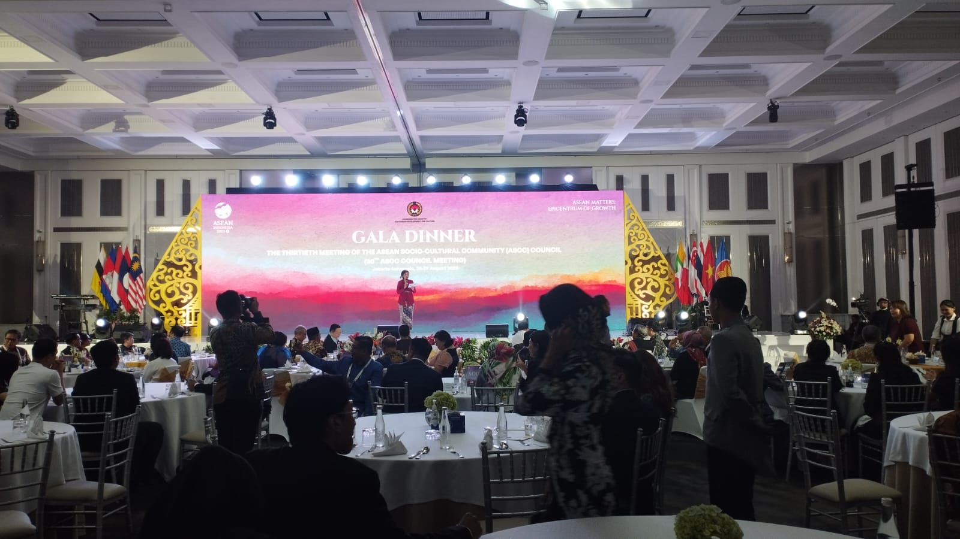

Delegates of the 30th ASEAN Socio Cultural Community (ASCC) meeting were served with authentic Indonesian food during a gala dinner at the Langham Hotel Ballroom, Jakarta, on Tuesday (08/29/2023). (Tri Antoro/InfoPublik)

